How to upgrade SP3

Step 1. Login Tenda Beli, tap the managed device.

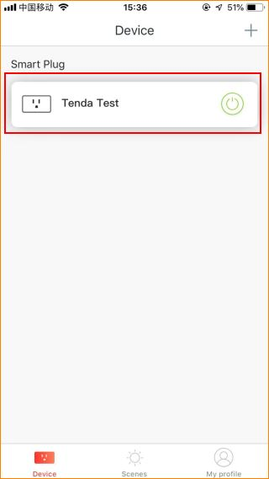

Step 2. Tap the “…” on the top right.
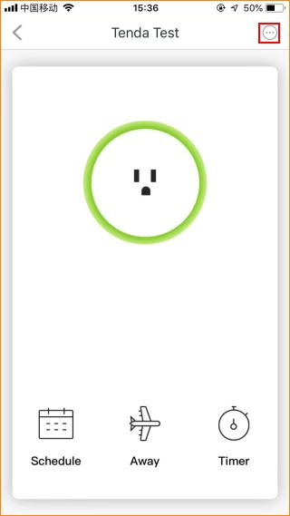

Step 3. Tap “Check the Firmware”.

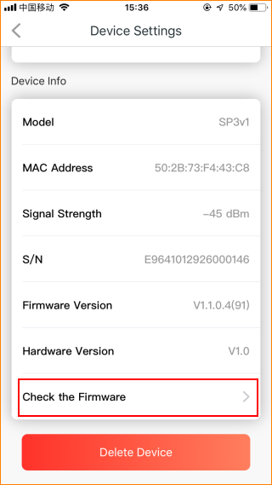

Step 4. Tap “Upgrade now”.

